Assignment Submission of Intro to Web Dev.
Ques 1. Explain the difference between frontend, backend, and full-stack development with
suitable real-world examples.

Ans - Frontend Development
Frontend development is defined as the part of a website that users can see and use. It includes the design, buttons, images, menus, and other things shown on the screen.
Example: On Amazon, the search bar, product images, and "Add to Cart" button are part of the frontend.
Backend Development
Backend development is defined as the part of a website that works behind the scenes. It stores data, processes requests, and connects the website to the database. Users cannot see this part.
Example: When you log in to Instagram, the backend checks your username and password and opens your account.
Full-Stack Development
Full-stack development is defined as the development of both the frontend and backend of a website. A full-stack developer can create the complete website from start to finish.
Example: A developer creating an online shopping website designs the pages, manages user accounts, and stores product details in the database.
Difference
Frontend | Backend | Full-Stack
Visible to users | Works behind the scenes | Includes both frontend and backend
Uses HTML, CSS, JavaScript | Uses Java, Python, PHP, Node.js | Uses both frontend and backend technologies
Focuses on design and user interface | Focuses on data and server | Builds the complete website

Ques 2. Create a simple diagram showing how the client-server model works in web architecture.
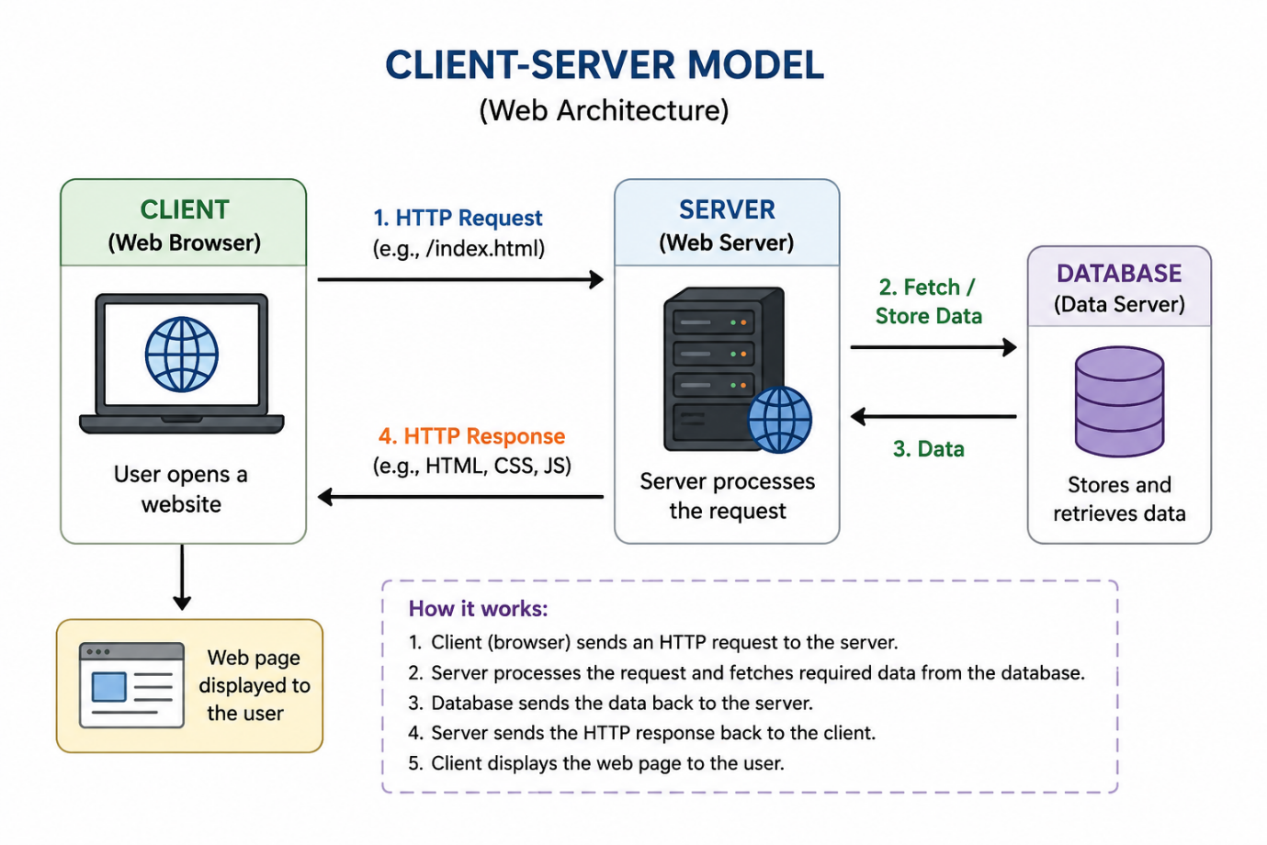

Ques 3. Describe how a browser requests and displays a web page from a web server.

Ans : When a user enters a website address (URL) in the browser and presses Enter, the browser sends an HTTP request to the web server.
The web server receives the request and processes it. If required, it gets the necessary data from the database.
After processing the request, the server sends an HTTP response containing the web page files (HTML, CSS, JavaScript, images, etc.) back to the browser.
Finally, the browser reads these files and displays the web page on the user's screen.
Steps Involved
- User enters a website URL in the browser.
- The browser sends an HTTP request to the web server.
- The server processes the request and retrieves data if needed.
- The server sends an HTTP response to the browser.
- The browser displays the web page to the user.
Ques 4. Identify and list the tools required to set up a web development environment. Explain the purpose of each.
Ans :
Tool | Purpose
Visual Studio Code (VS Code) | A code editor used to write and edit HTML, CSS, JavaScript, and other programming languages.
Web Browser (Google Chrome, Microsoft Edge) | Used to run and test web pages. It also helps inspect and debug websites.
Git | A version control tool used to track changes in code and manage projects.
GitHub | An online platform used to store code, share projects, and collaborate with others.
Node.js | Provides a runtime environment to run JavaScript outside the browser and install development packages.
npm (Node Package Manager) | Comes with Node.js and is used to install and manage project libraries and packages.
Live Server (VS Code Extension) | Automatically refreshes the web page whenever changes are made to the code.

5. Explain what a web server is and give examples of commonly used servers.
Ans : A web server is software (or a computer) that stores website files and sends them to the user's browser when a request is made. It receives the browser's request, processes it, and returns the required web page.
Examples of Commonly Used Web Servers
- Apache HTTP Server – One of the most popular open-source web servers used to host websites.
- Nginx – A fast and lightweight web server commonly used for high-traffic websites.
- Microsoft IIS (Internet Information Services) – A web server developed by Microsoft for Windows systems.
- LiteSpeed – A high-performance web server known for its speed and security.
Example : When you open www.amazon.com , your browser sends a request to Amazon's web server. The server processes the request and sends the website files back to your browser, which then displays the web page.
Ques 6. Define the roles of a frontend developer, backend developer, and database administrator in a project.
Ans : Frontend Developer
A Frontend Developer is a software developer who is responsible for creating the part of a website or web application that users can see and interact with. They design the user interface (UI) and improve the user experience (UX) by developing web pages that are attractive, responsive, and easy to use. Frontend developers use technologies such as HTML, CSS, and JavaScript to build the layout, buttons, menus, forms, images, and other visual elements of a website.
Roles and Responsibilities:
- Designs the user interface of the website.
- Creates responsive web pages for different devices.
- Improves the user experience by making the website easy to use.
- Works with backend developers to connect the frontend with the server.
Example: Designing the homepage, navigation menu, and product pages of an e-commerce website.

Backend Developer
A Backend Developer is a software developer who is responsible for developing the server-side part of a website or web application. They write the application logic, manage user requests, connect the website to the database, and ensure that all features work correctly. Backend developers use programming languages such as Java, Python, PHP, Node.js, or C# to build the server-side functionality.
Roles and Responsibilities:
- Develops the business logic of the application.
- Handles user authentication and login.
- Connects the website with the database.
- Processes requests and sends responses to the frontend.
- Ensures the security and performance of the application.
Example: Processing online payments, verifying user login details, and managing customer orders.

Database Administrator (DBA)
A Database Administrator (DBA) is a professional who is responsible for managing, organizing, and maintaining the database of a website or application. The DBA ensures that data is stored securely, backed up regularly, and can be accessed quickly whenever needed. They also monitor the database to improve its performance and protect it from unauthorized access.
Roles and Responsibilities:
- Creates and manages databases.
- Stores and organizes application data.
- Performs regular database backup and recovery.
- Maintains database security and user permissions.
- Optimizes database performance for faster access.
Example: Managing customer records, product details, and order history in an online shopping website.

Ques 7. Install VS Code and configure it for HTML, CSS, and JavaScript development. Take a screenshot of the setup.

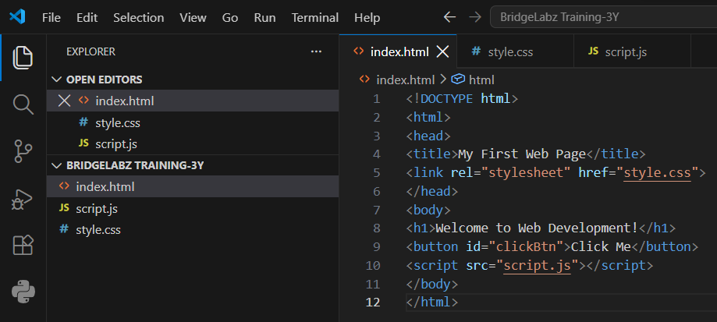
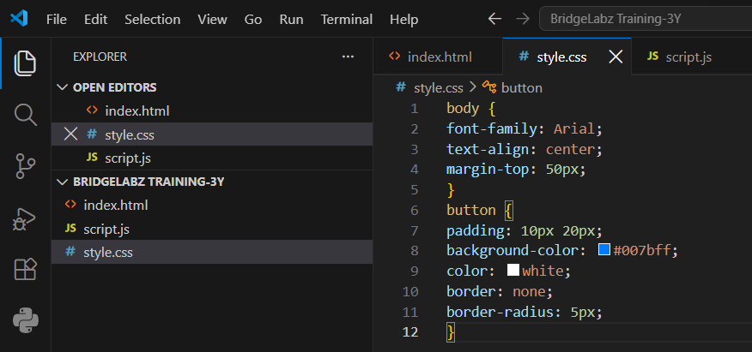

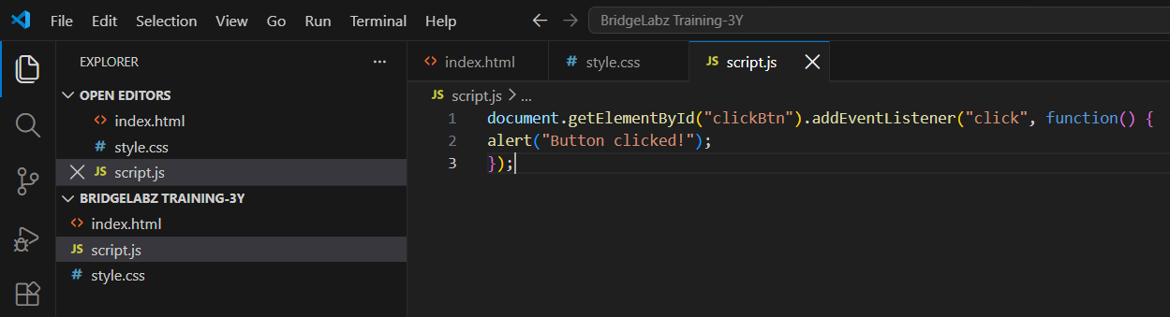

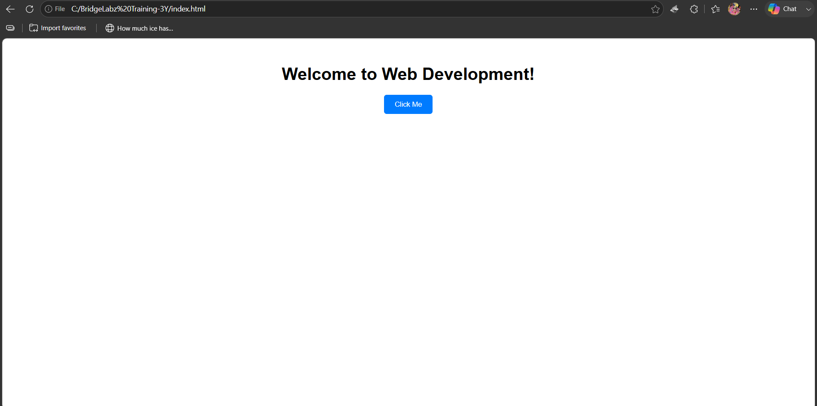
Ques 8. Explain the difference between static and dynamic websites. Provide an example of
each.
Ans : Static Website
A static website is a website whose content remains the same for every user. The web pages are created using HTML and CSS, and they do not change unless the developer manually updates the code. Static websites are simple, fast, and easy to develop, but they do not support user interaction or real-time content updates.
Characteristics:
- Same content for every user.
- Easy to create and maintain.
- Faster loading speed.
- Does not require a database.
Example:
A personal portfolio website or a college information website with fixed content.

Dynamic Website
A dynamic website is a website whose content can change based on the user's actions, preferences, or data stored in a database. Dynamic websites use server-side programming languages such as PHP, Python, Java, or Node.js along with databases like MySQL or MongoDB. These websites are interactive and can display different information to different users.
Characteristics:
- Content changes dynamically.
- Uses a database to store and retrieve data.
- Supports user interaction such as login and registration.
- Suitable for large and interactive websites.
Example:
Amazon, Facebook, Instagram, and YouTube are dynamic websites because their content changes according to each user's account and activities.
Difference Between Static and Dynamic Websites :
Static Website | Dynamic Website
Content remains the same. | Content changes based on the user or data.
Developed mainly using HTML and CSS. | Uses HTML, CSS, JavaScript, and server-side languages.
Ques 9. Research and list five web browsers. Explain how rendering engines differ between
them.
A web browser is a software application that allows users to access and view websites on the Internet. Different web browsers use different rendering engines to display web pages. A rendering engine reads the HTML, CSS, and JavaScript code of a website and converts it into the webpage that we see on the screen.
Five Popular Web Browsers
1. Google Chrome
Google Chrome is one of the most popular web browsers in the world. It is known for its speed, security, and user-friendly interface.
- Rendering Engine: Blink

2. Mozilla Firefox
Mozilla Firefox is a free and open-source web browser. It is popular for its privacy features and customization options.
- Rendering Engine: Gecko

3. Microsoft Edge
Microsoft Edge is the default web browser for Windows. It is fast, secure, and based on Chromium.
- Rendering Engine: Blink

4. Apple Safari
Safari is the default web browser for Apple devices such as Mac, iPhone, and iPad. It is designed for better performance and battery efficiency on Apple devices.
- Rendering Engine: WebKit

5. Opera
Opera is a lightweight web browser that provides built-in features such as a VPN, ad blocker, and battery saver.
- Rendering Engine: Blink

Difference Between Rendering Engines
Web Browser | Rendering Engine | Description
Google Chrome | Blink | Fast rendering engine developed by Google.
Mozilla Firefox | Gecko | Open-source rendering engine developed by Mozilla.
Microsoft Edge | Blink | Uses the same Blink engine as Chrome for better compatibility.
Apple Safari | WebKit | Developed by Apple and optimized for Apple devices.
Opera | Blink | Uses Blink for fast browsing and modern web support.

Ques 10. Draw a labeled diagram showing the basic web architecture flow — client, server,
database, and APIs.
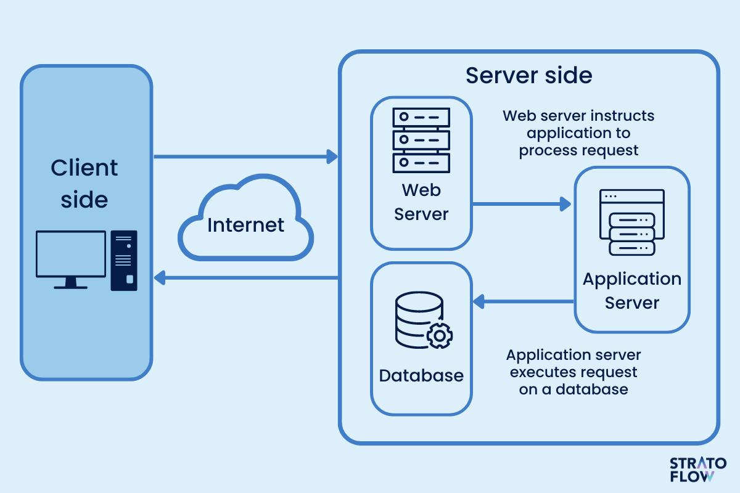
The client (browser) sends a request to the web server through the Internet. The server processes the request, retrieves data from the database, and sends the response back to the client to display the web page.
> Client (Web Browser) → sends HTTP Request
> Web Server → processes the request
> API → communicates with external/internal services
> Database → stores and retrieves data
> Web Server → sends HTTP Response
> Client → displays the webpage

